Software Engineering Management

Group 9 - Alex, Ash, Gursaiv, Shriya, Sam, Will

**Table of Contents**

***Sketches 2***

***Game Mechanics 3***

***User Requirements 4***

***Market Research 8***

***Full Requirements 12***

# Sketches

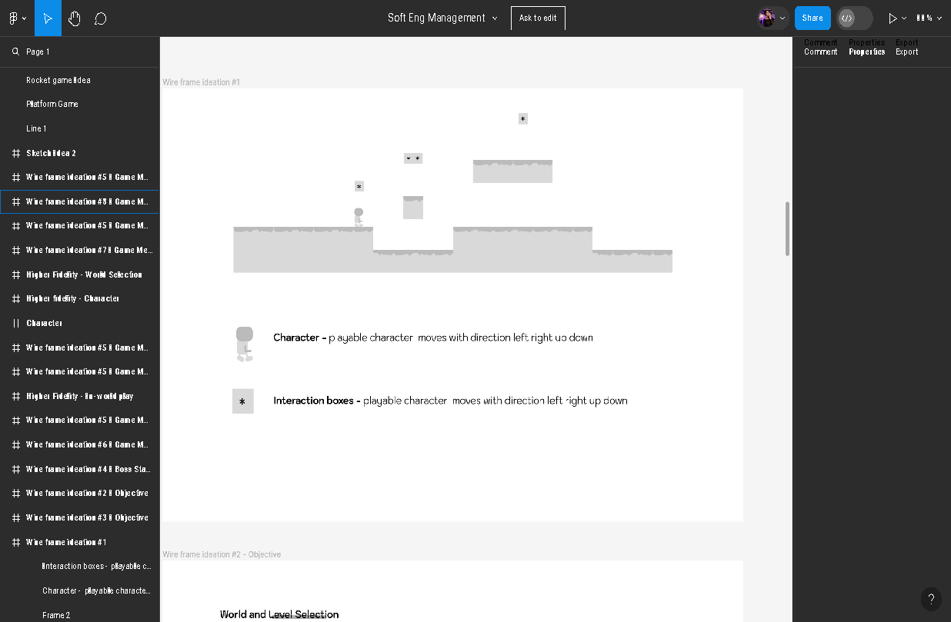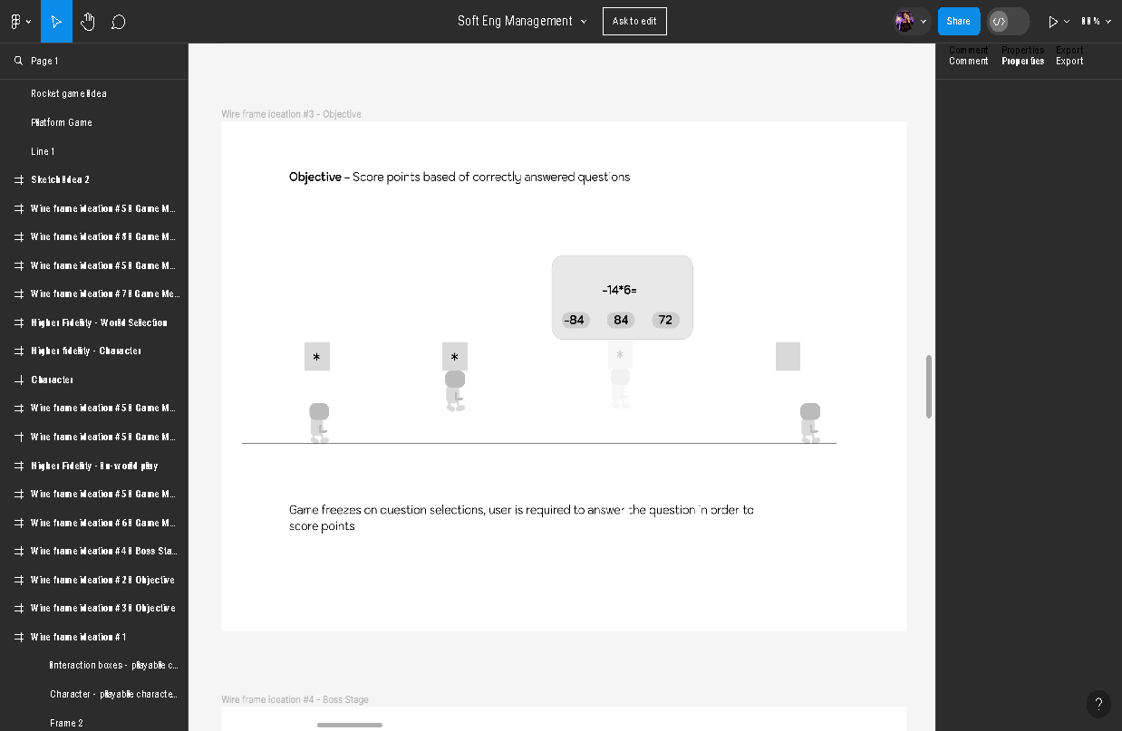

# Game Mechanics



# User Requirements

## Stakeholders

The main stakeholders are the players. These players will be from the ages of 11- 14; however, parents may also be stakeholders to ensure that the game is suitable for their child. Keeping an eye out for any explicit content throughout the game that could harm the child. Teachers may also be stakeholders, as the game may be beneficial to helping students learn the school curriculum, along with school administrators.

Our team and the people we collaborate with, along with potential publishers and investors will also be potential stakeholders.

## 

## Personas

### Persona 1

**Name:** Daniel

**Age:** 11 years old

**Demographic information:**

* Lives in a suburban area, attends a local upper school.
* Enjoys spending time with friends, playing sports, and exploring hobbies like drawing and reading

**Computer competency:**

- at ease playing games and learning on computers and mobile devices.

- possesses a basic understanding of how to operate a mouse, touch screen, and navigate menus while according to on-screen directions.

**Requirements and preferences for software:**

* favours immersive learning environments, captivating gameplay mechanics, and vibrant, eye-catching graphics.
* enjoys playing video games that combine fun and difficulty with room for exploration and discovery.

### Persona 2

**Name:** Ellie

**Age:** 14 years old

**Demographic information:**

* Lives in an urban area
* Attends a large upper school.
* Interested In technology, science and STEM-related subjects.
* Enjoys participating in coding club, robotics clubs and other extracurricular activities.

**Computer competency:**

* Advanced knowledge with computers and technology.
* Comfortable using coding languages, software development tools, and educational platforms.
* Enjoys exploring complex systems and problem solving challenges.

**Requirements and preferences for software:**

* looks for mentally challenging games that provide chances for logical reasoning, strategic decision-making, and critical thinking. Appreciates games that offer thorough justifications of mathematical ideas and concepts.

### Persona 3

**Name:** Sarah

**Age:** 37 years old

**Demographic information:**

* A working mother of 2, including an 11-year-old daughter who is interesting in playing an educational math game.
* She lives in a suburban neighbourhood and works full-time as a marketing manager at a local company.
* She is passionate about her children’s education and wants to ensure they have access to safe and enriching learning experiences.

**Computer competency:**

* Sarah has basic to moderate proficiency with computers and mobile devices.
* She uses technology daily for work and personal tasks, such as browsing the internet, checking emails, and using social media.
* Although not completely tech-savvy as her children, Sarah is capable of navigating through software interfaces and settings.

**Concerns about preferences for software:**

* Sarah is cautious about the content her children consume online and wants to ensure that any games they play are safe, age-appropriate, and beneficial for their learning and development.
* She values games that offer educational value, promote critical thinking skills, and provide a positive and supportive learning environment.
* Sarah also prefers games that have clear instructions, parental controls, and options for monitoring her children’s progress and activity within the game.

### 

### Persona 4

**Name:** Mr. Rodriguez

**Age:** 32 years old

**Demographic information:**

* Upper school maths teacher who is passionate about engaging his students in creative and interactive ways.
* He teaches a diverse group of students with varying levels of mathematical proficiency and learning styles.
* He's always looking for innovative teaching tools and resources to enhance his lessons and make learning more enjoyable for the students.

**Professional Background:**

* Holds a bachelor’s degree in mathematics and a teaching certification.
* Has been teaching upper school maths for six years
* Is experienced with using technology in the classroom, including interactive whiteboards, educational software, and online resources.

**Computer Competency:**

* Advanced proficiency with computers and educational technology.
* Familiar with various software programmes and online platforms commonly used in education.
* Comfortable integrating technology into his teaching practice.

**Goals and preferences for software:**

* Looking for educational games and resources that align with the curriculum standards and learning objectives for his math class.
* Values games that offer engaging and interactive learning experiences, promote critical thinking and problem-solving skills, and provide opportunities for differentiated instructions to meet the needs of all his students.

## 

## User Goals

Daniel: “I want to play an educational maths game that is both entertaining and challenging so I can improve my maths skills and be caught up on the curriculum materials for lesson time”

Ellie: “As a person who loves technology, I want to develop my critical thinking, and logical reasoning. I love stimulating my brain”.

Sarah: “I want to play the educational maths game alongside my child to ensure it is safe, appropriate, and beneficial for their learning and development.”

Mr. Rodriguez: “I want to explore educational games to enhance my students’ learning experience at home and reinforce mathematical concepts in a fun and interactive way.”

### Requirements

### Students

**Usage:** The game would mainly be used by students as an engaging and interactive learning tool to enhance their arithmetic abilities. Either alone or in groups, they would engage in the game as part of their homework or during class teaching.

**User Expectations:** To keep them engaged and interested, students would seek out interesting gameplay mechanisms, unambiguous directions, and a range of maths topics and difficulties. In order to monitor their development over time, they would also anticipate receiving feedback from the game regarding their performance and advancement.

#### 

### Parents

**Usage:** The game would be used by parents to encourage their kids' learning outside of the classroom and make sure they are interacting with appropriate and helpful educational materials.

**User Expectations:** To keep their kids safe while they play, parents would search for age-appropriate content, definite educational goals, and strong safety measures like parental controls and privacy settings. In order to help them keep an eye on their child's learning, they would also anticipate the game to offer data about their child's performance and advancement.

### 

### Teachers:

**Usage:** The game would be used by teachers as an extra teaching aid in the classroom to help pupils learn mathematical concepts and participate in hands-on activities.

**User Expectations:** In order to effectively integrate educational games into their teaching, teachers should look for games that meet the learning objectives and curriculum standards for their class and provide opportunities for differentiation to meet the needs of a diverse student body.

### School Administrators:

Usage: The game would be used by school officials to help the school's educational programmes and goals, such as encouraging STEM education or raising student competency in maths.

User Expectations: Administrators at schools would search for proof that the game is helping students learn more, such higher math test scores or higher levels of engagement. They would also anticipate that the game would offer chances for teacher training and professional growth, as well as comply with the school's technological needs and financial restrictions.

# Market Research

## General Maths Games for 11-14 years in market:

<https://www.topmarks.co.uk/maths-games/11-14-years/number>

#### Equivalent fraction finder (Interactive fraction matching)

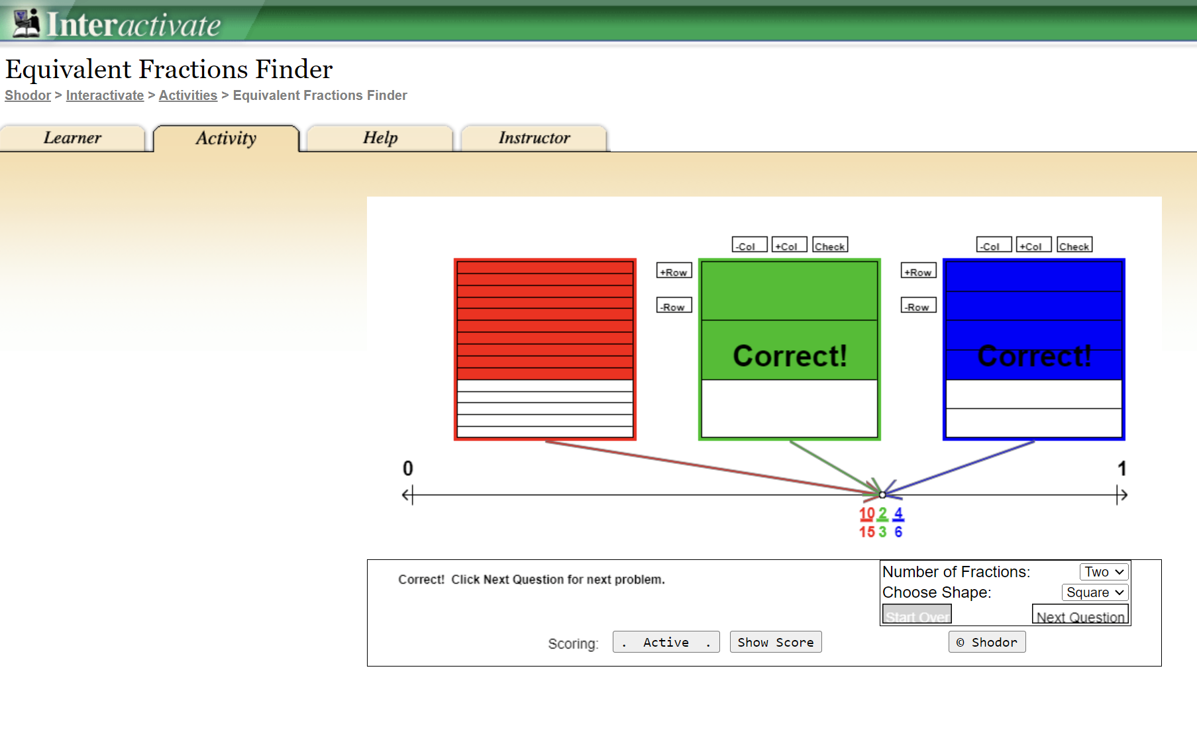

#### Ratio Rumble: for ratio and proportion

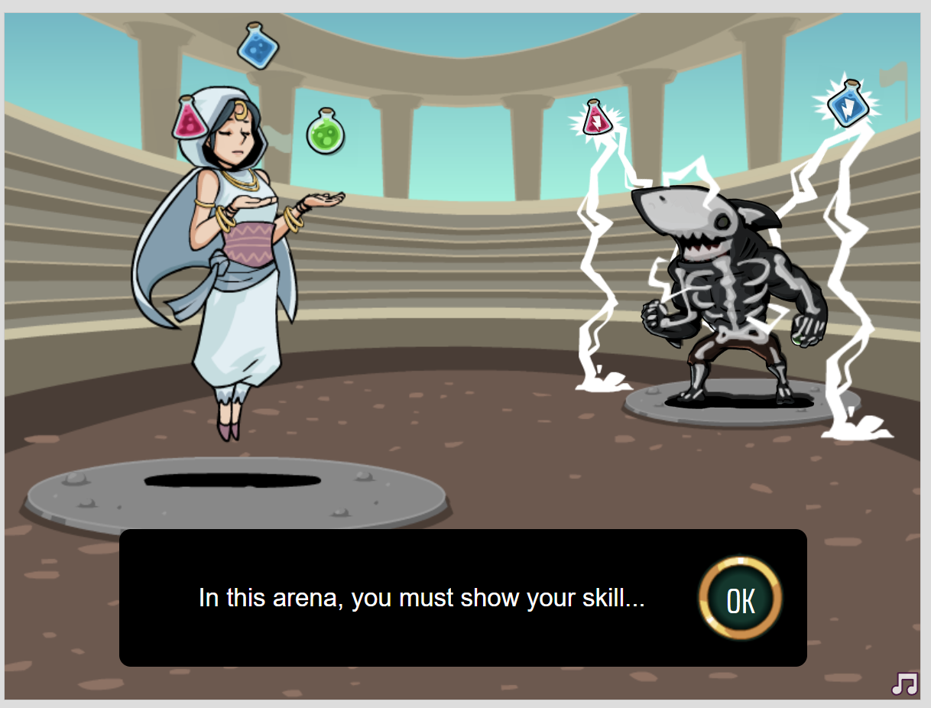 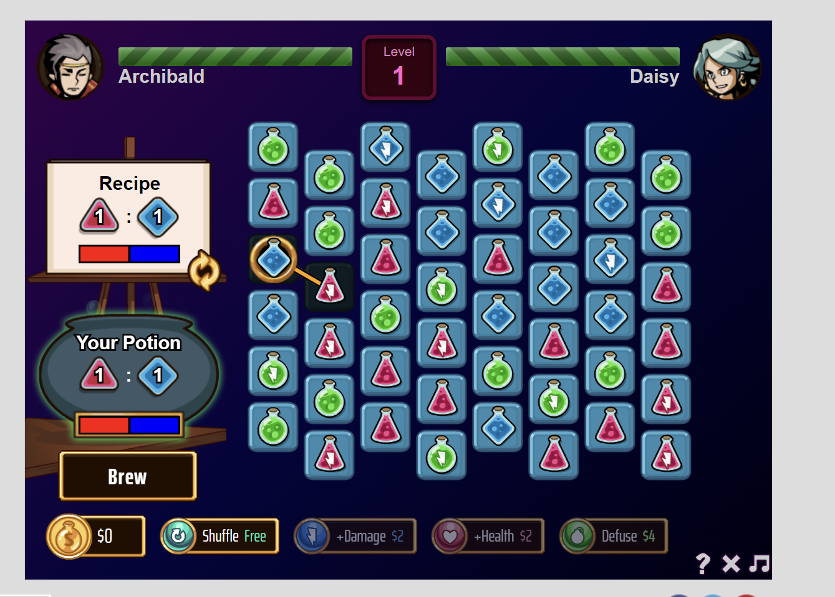

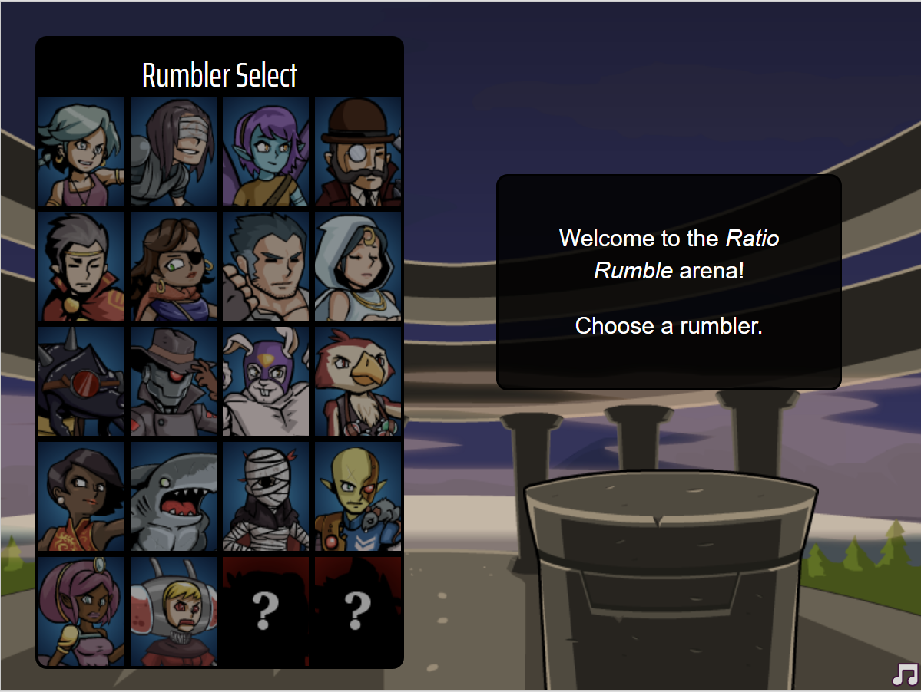

Pros: Ability to choose characters, interactive gameplay with instant feedback, app has collaborated with teachers to provide link of this game in class to students.

#### Minus Miners: Calculation for integers and decimals

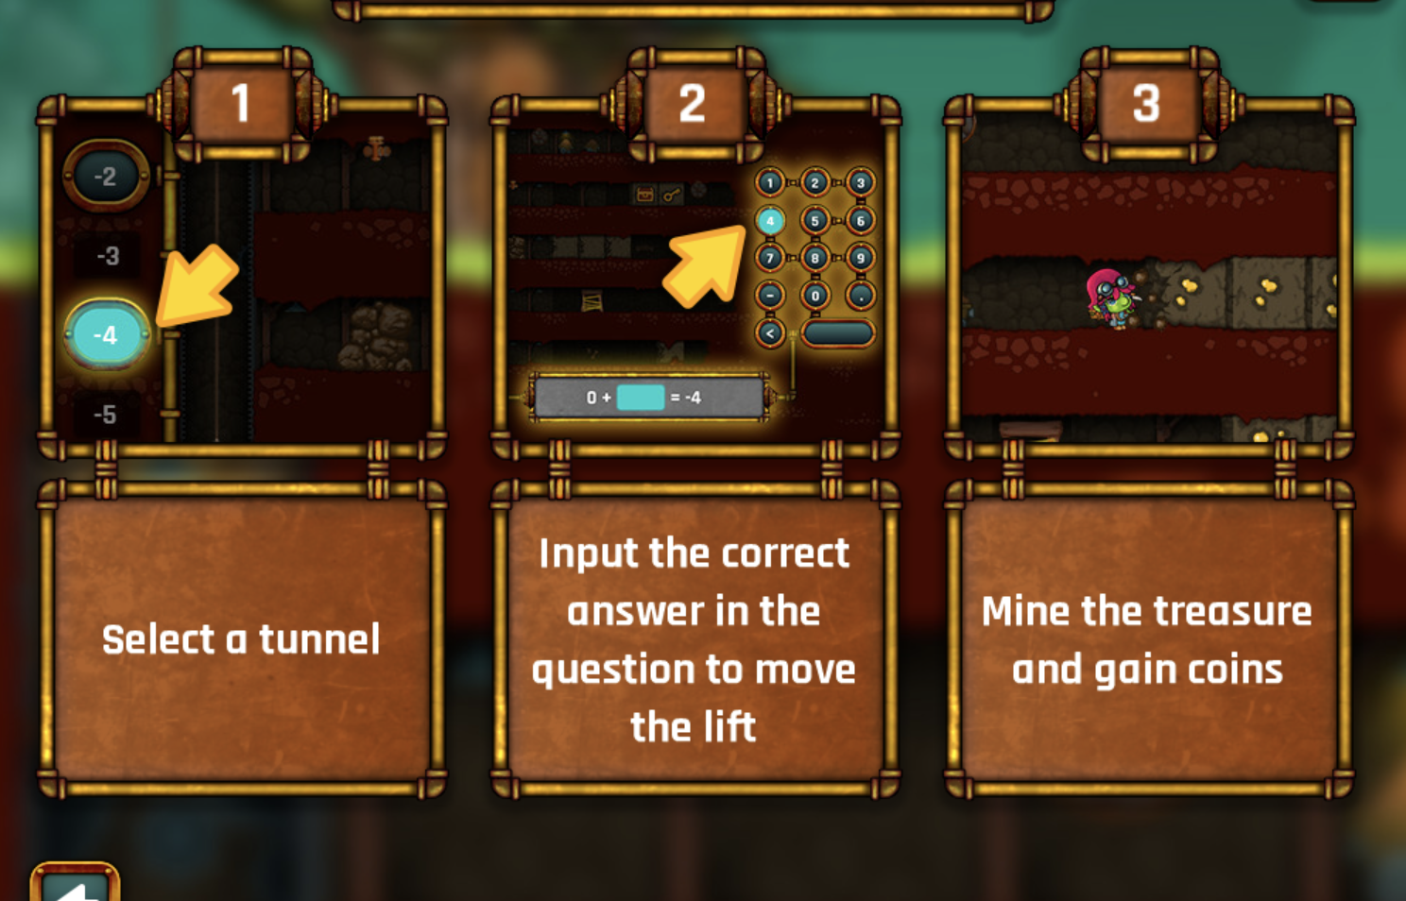 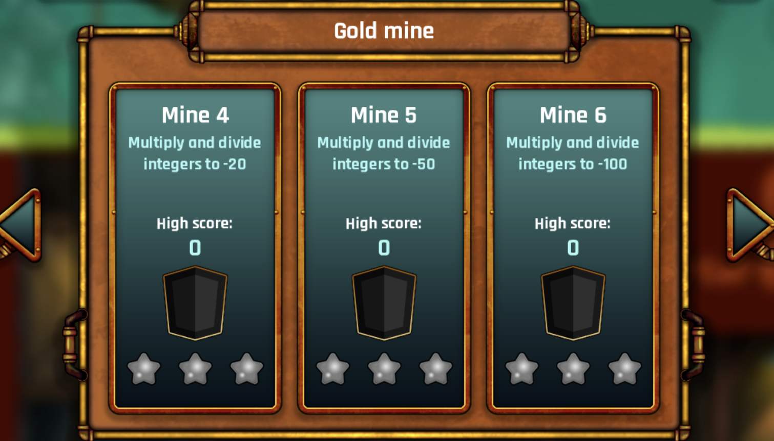

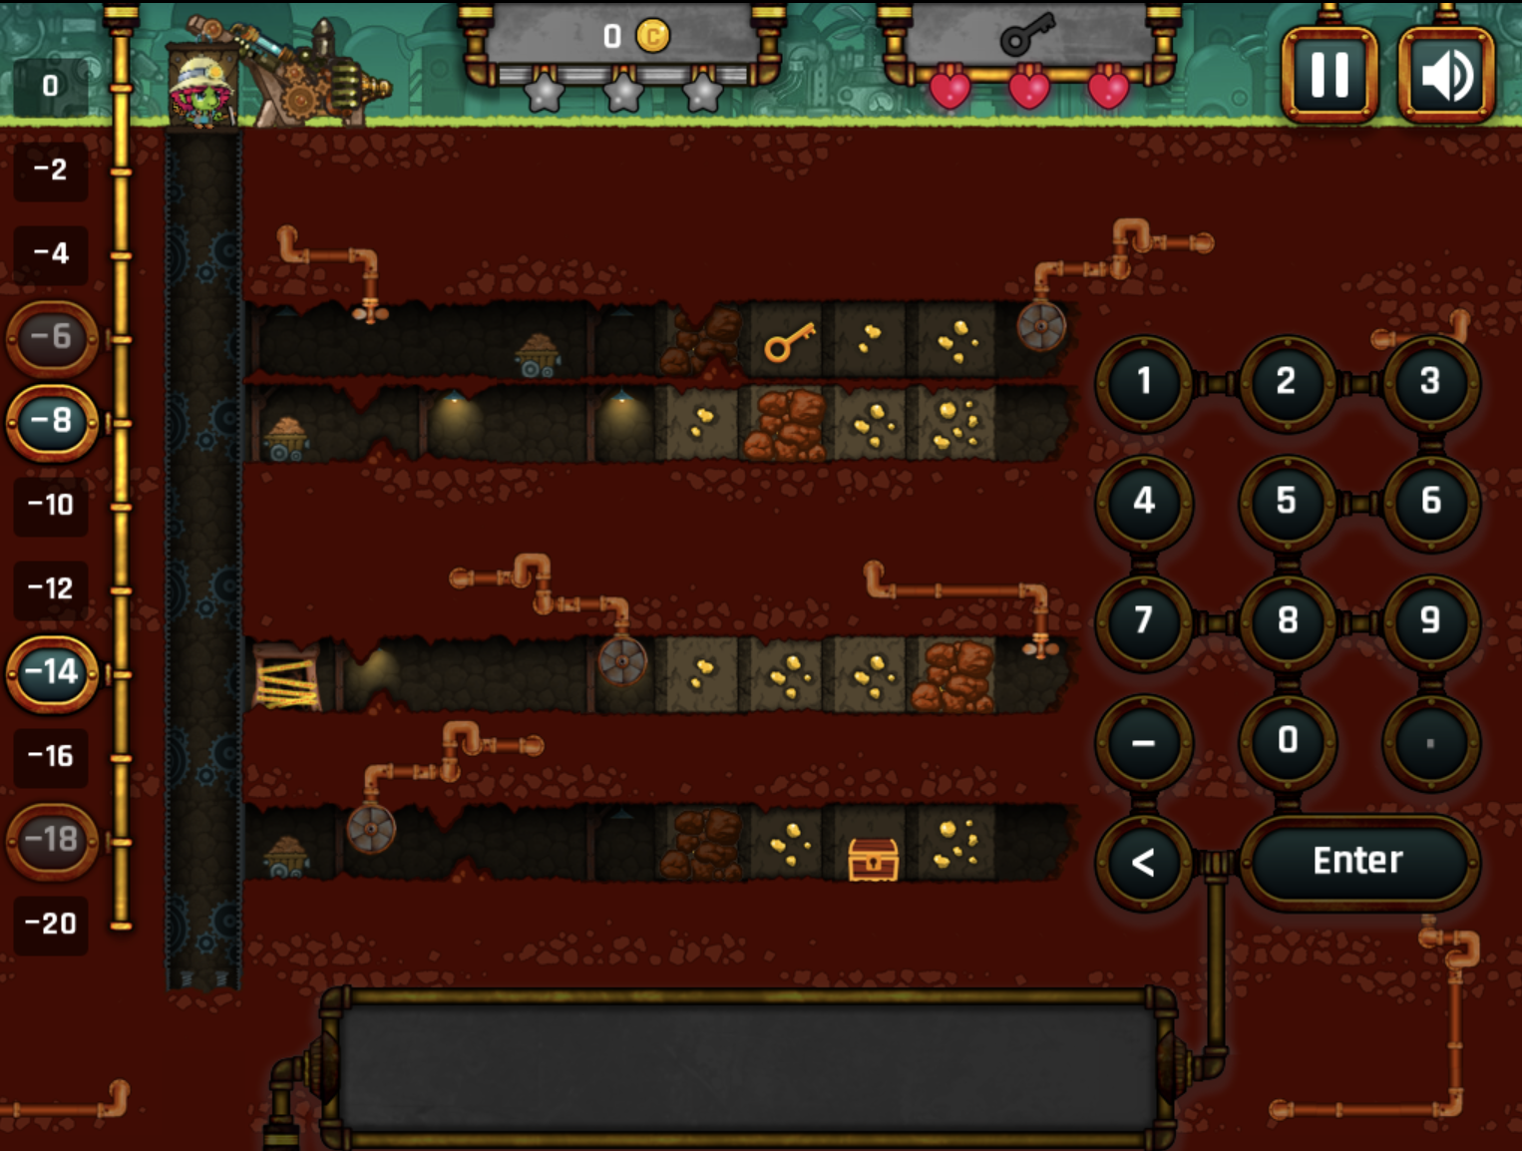 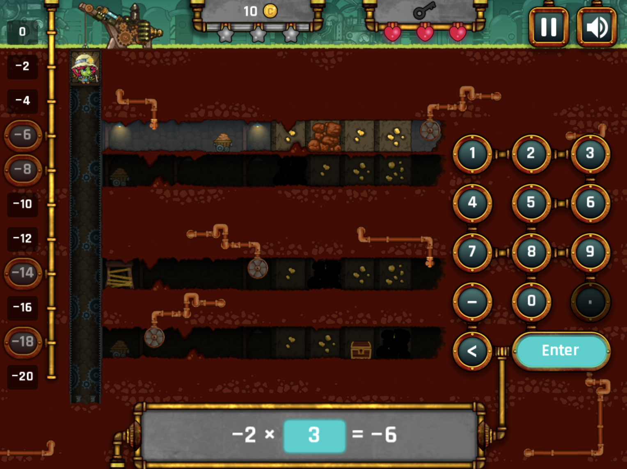

Pros: Unique concept, good theme integration, easy input of answers

#### 

#### Deep Sea Dual : addition game to reach a given number using specified count of numbers

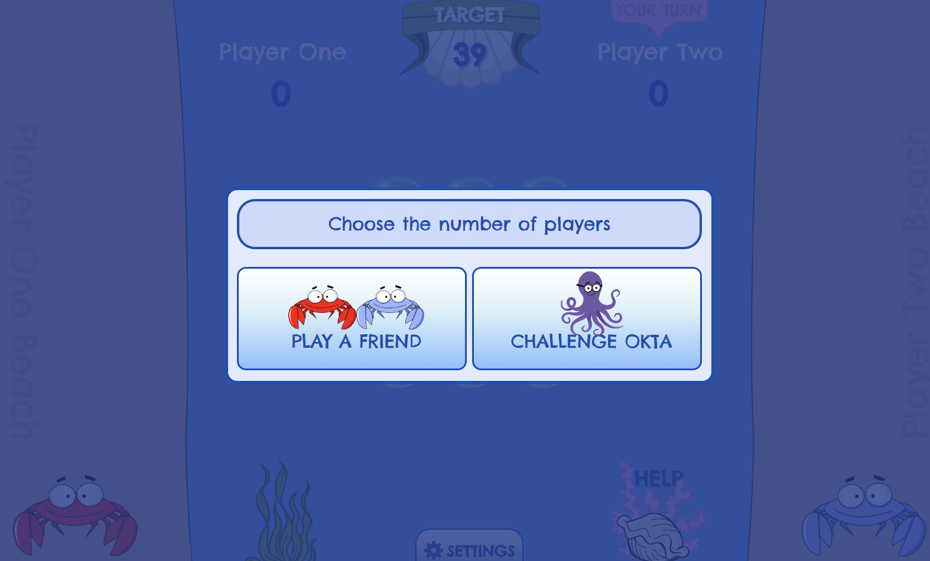 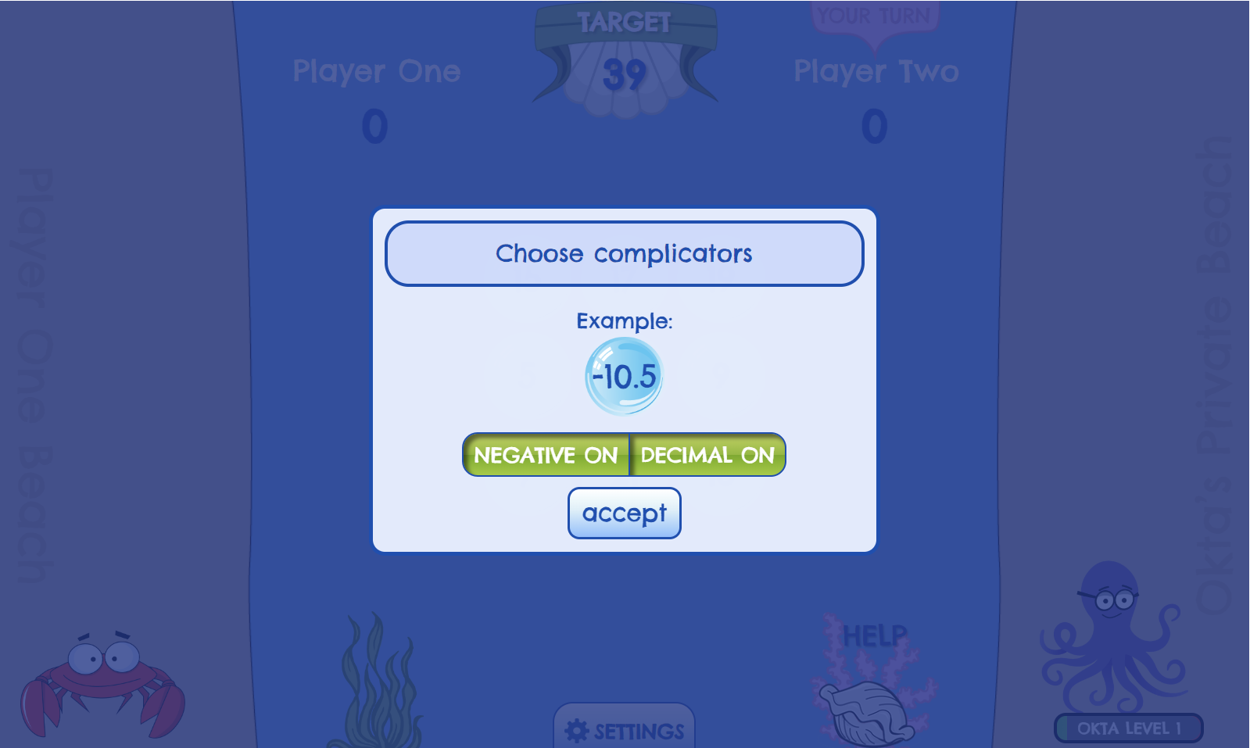

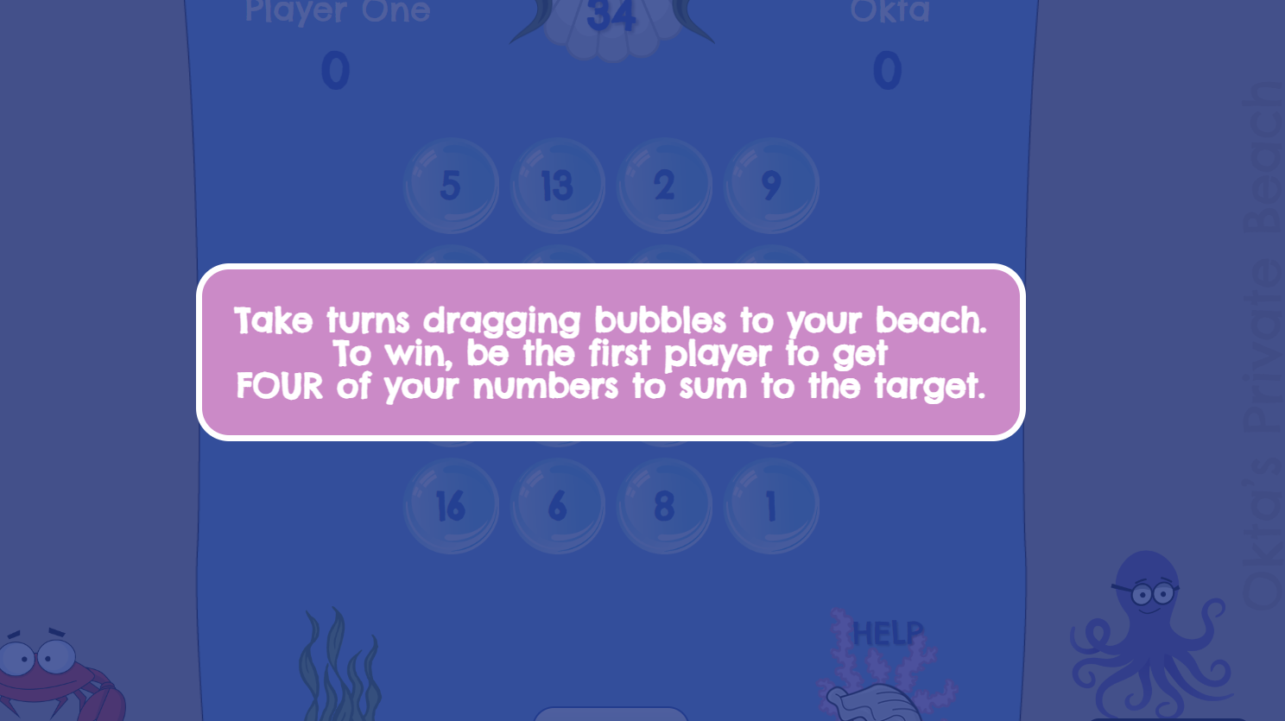 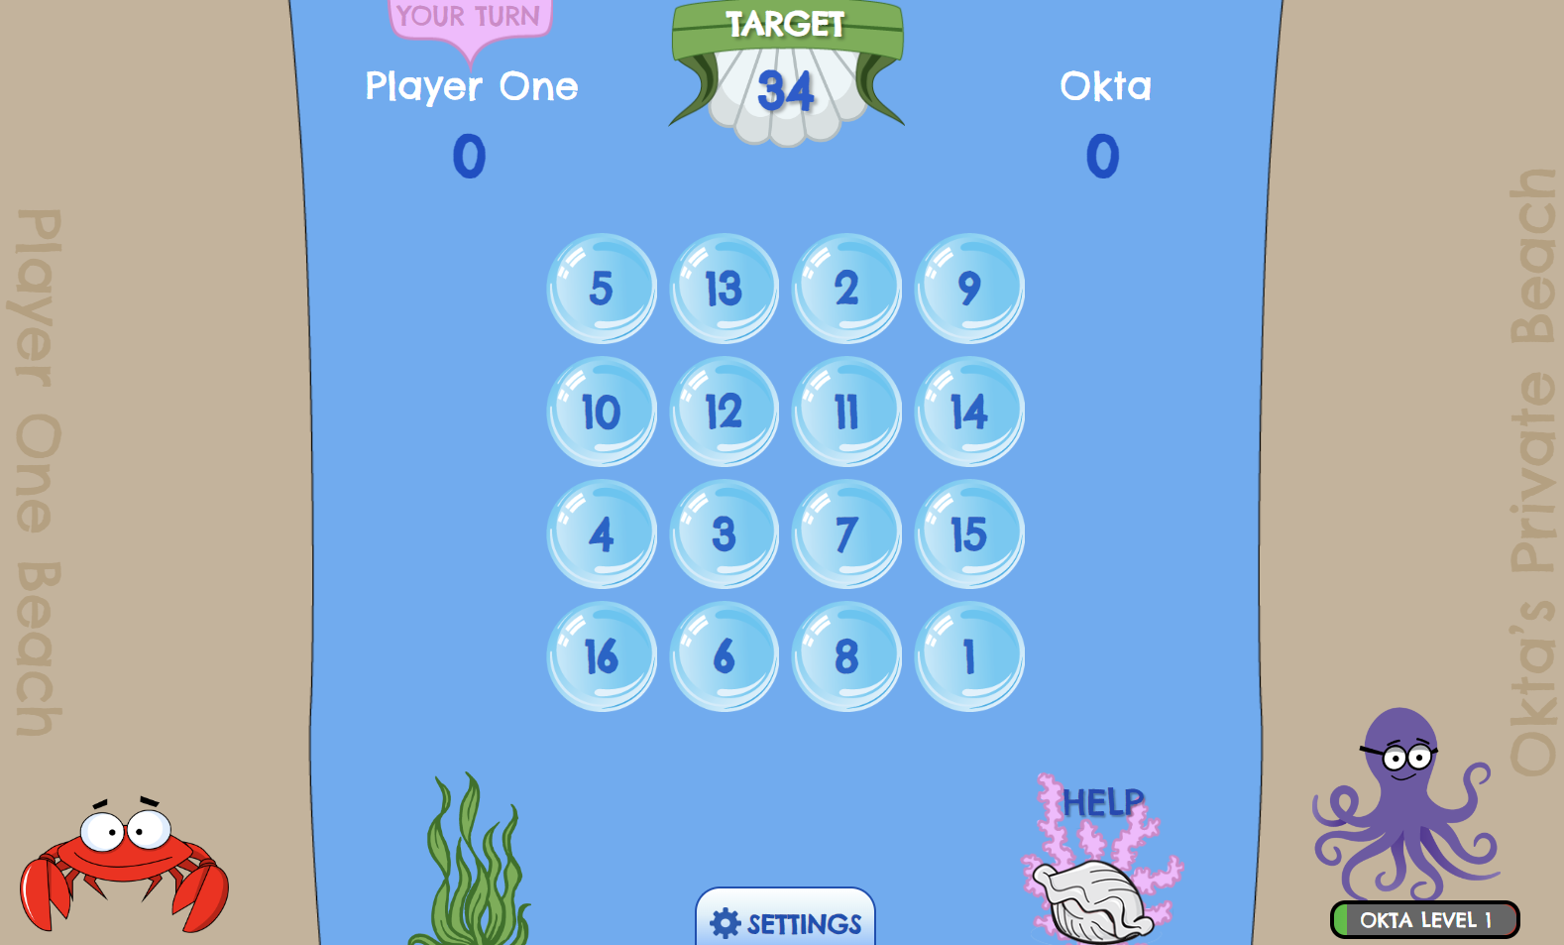

Pro: The level of difficulty change is very transparent, and you can play with a friend.

### Similar Games:

#### Tommy’s Trek – Times Table

<https://mathsframe.co.uk/en/resources/resource/318/Tommys-Trek-Times-Tables>

Tommy’s trek more games (similar 2D platform games, with a range of different maths problems) <https://mathsframe.co.uk/en/resources/category/587>

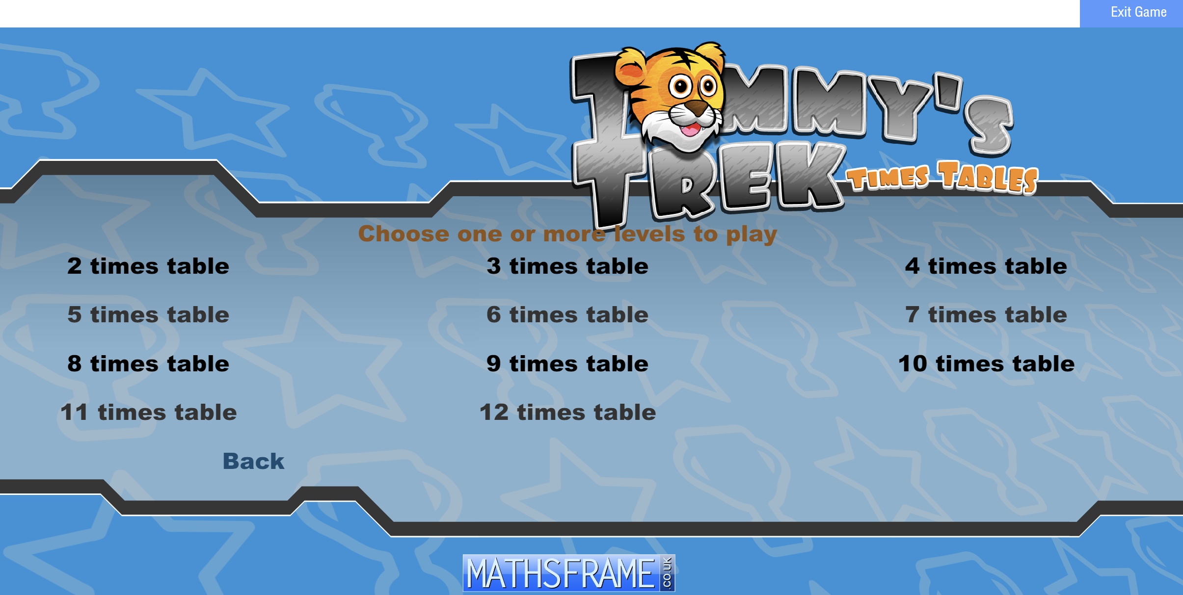 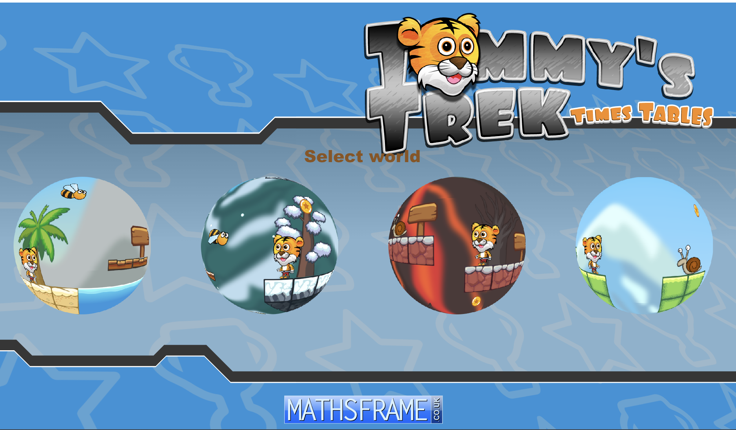

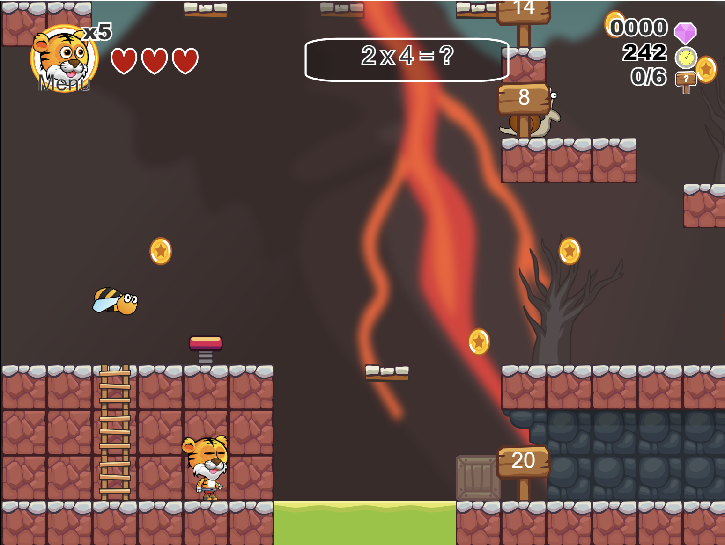

Age: Types of question vary depending upon the year of study (ranging from Y1 to Y5)

Difficulty level depends on the type of game, as multiple are available (from additions – calculation of fractions)

Pros: Good theme, using basic arrow keys for movement, based on timer – time left out of 160 secs is then converted to points.

Cons: Uses ‘ctrl’ key for jump and ‘up-arrow’ key for selecting correct answer.

#### Little Red Riding Hood – Maths game

(Developed in Unity using C#; not an actual game but just a prototype)

[https://www.br.freelancer.com/u/haidarabhirama/portfolio/2d-platformer-math-game-little-red-riding-hood-4493907#](https://www.br.freelancer.com/u/haidarabhirama/portfolio/2d-platformer-math-game-little-red-riding-hood-4493907)

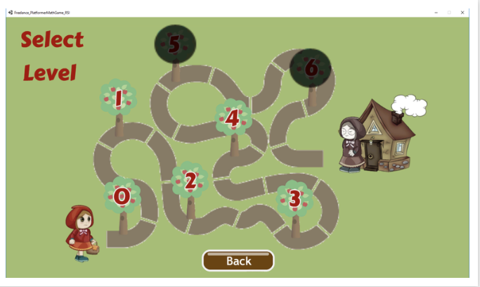 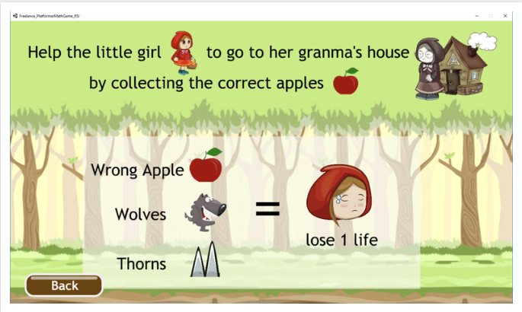

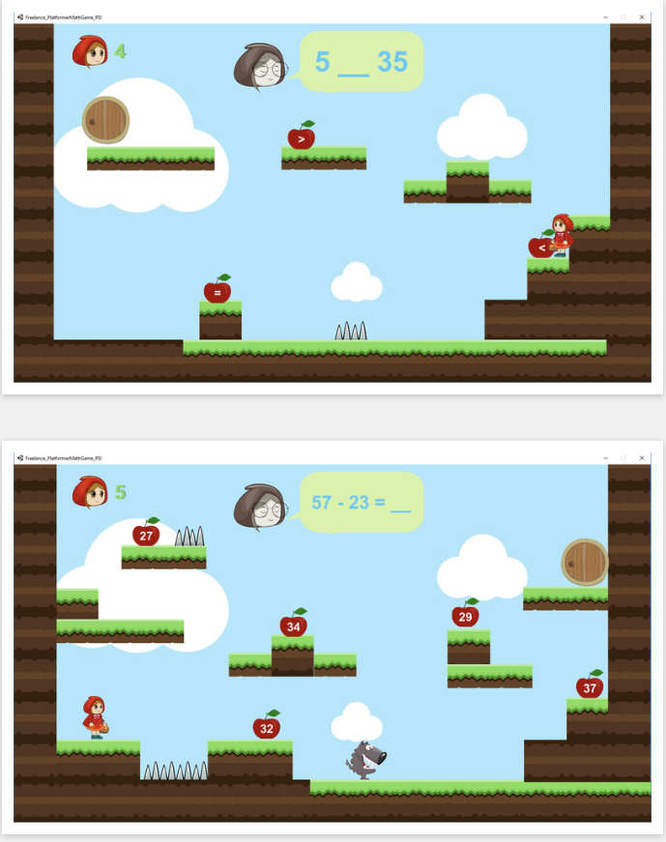 

Pros: Good storyline involved, tracks progress and difficulty level through pictorial map of level.

Cons: Looks childish (not suitable design for 11-14 year olds)

#### Math Duck

<https://www.calculators.org/games/math-duck/>

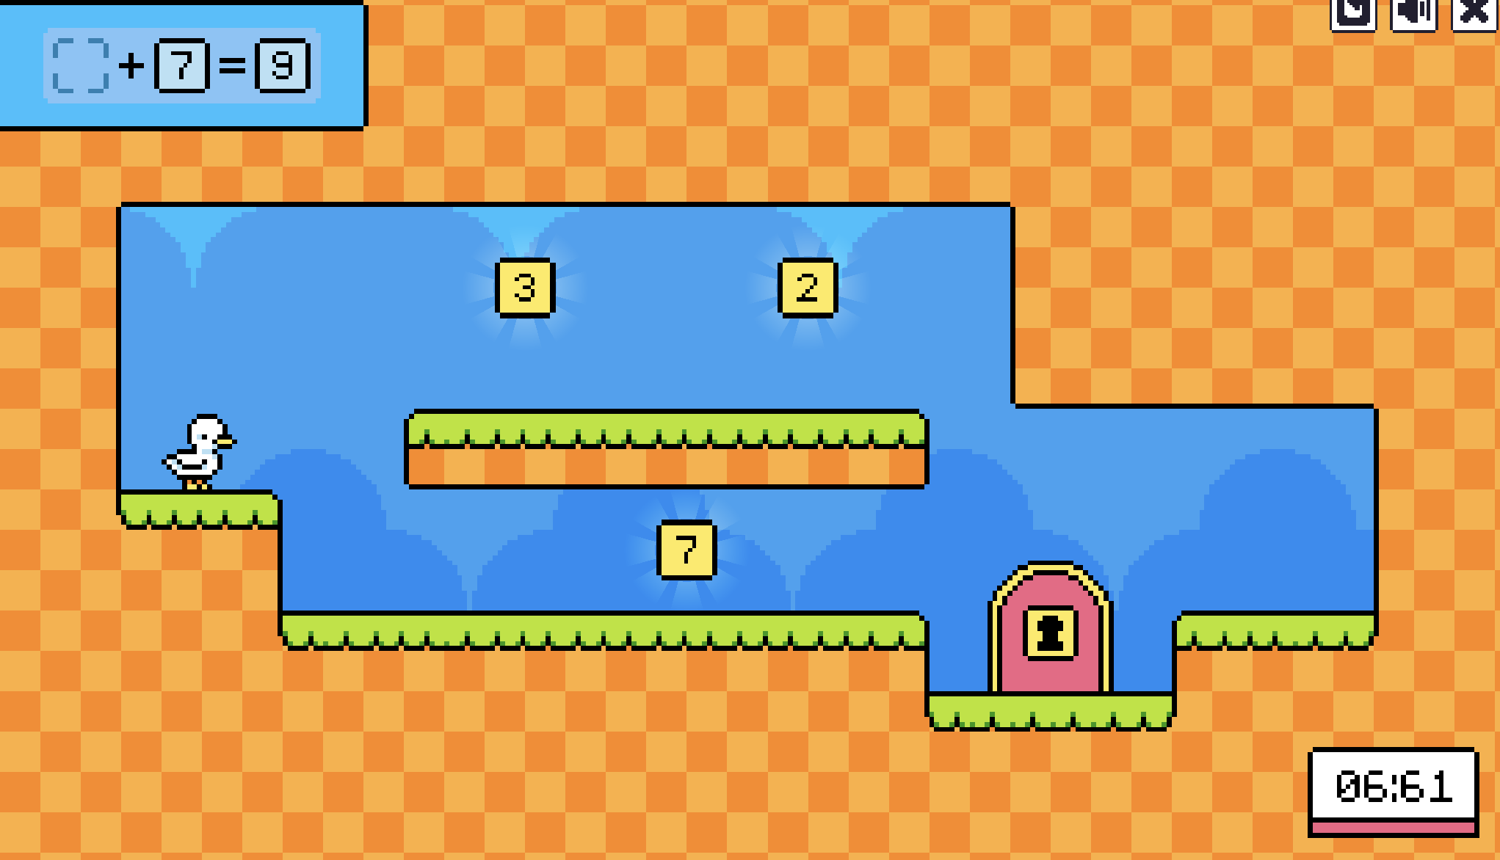 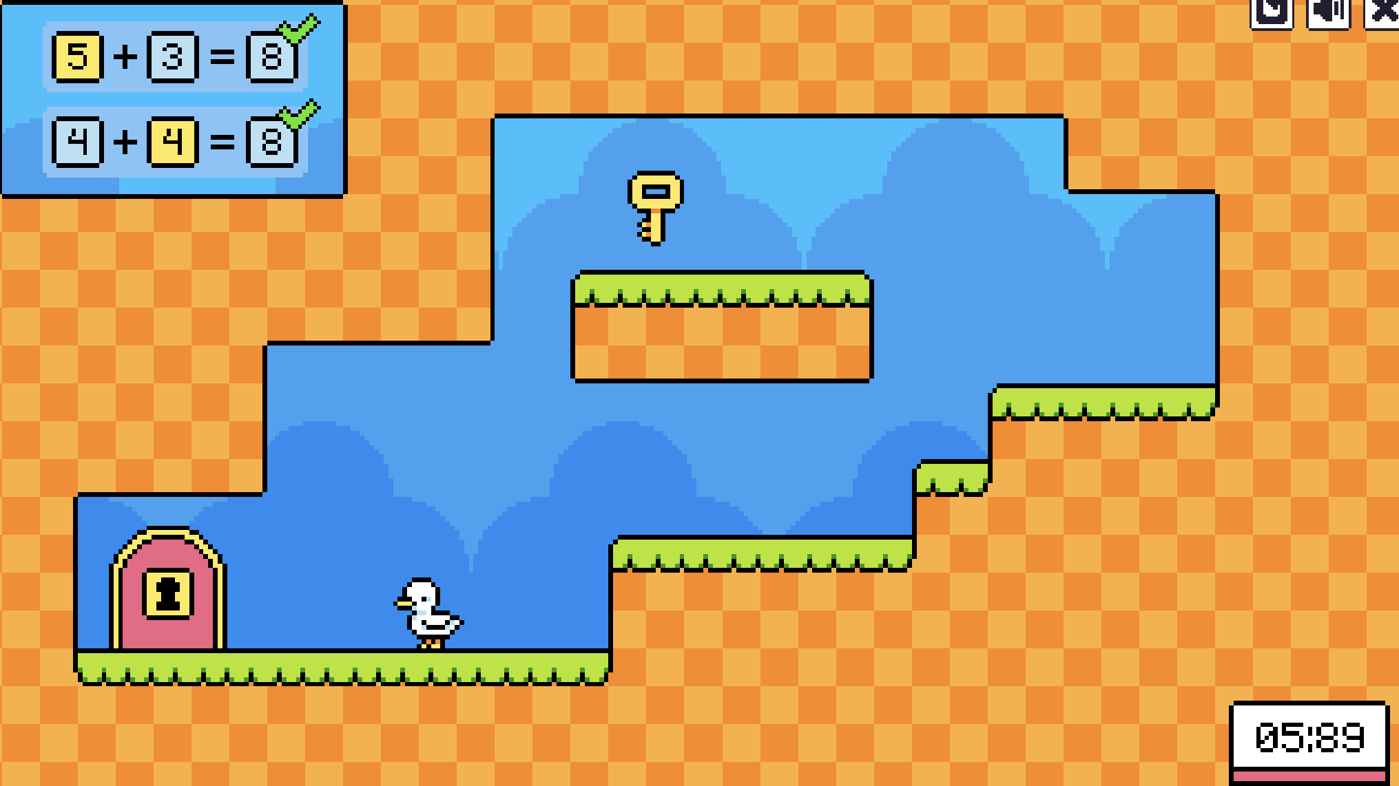

Pros: Easy to understand, only uses arrow keys through-out the game

Cons: The design makes it look more educational (might be a less useful thing in terms of children), Only 10 secs for 1 level

### Takeaways:

1. We can implement a story and character into the game for more engaging experience.
2. As discussed, we can have different worlds (also can be seen in the tommy’s trek game), but assign some meaning to each world.
3. Simpler use of either ‘arrow-keys’ or ‘wasd’ for movement.
4. We can implement the ‘Tommy’s world’ and ‘Minus Miners’ concepts and combine them for theme and visual representation of out game.
5. We could implement a section of ‘teachers’/ ’parents’ as an attempt to consider those stakeholders as well.
6. A lot of games for 11-14 years focused on multiplication, negative numbers, ratio-proportion, graphs, tables.

# Full Requirements

| Req No. | Requirement |
| --- | --- |
| **1.0** | **A player should be able to play a game of the platformer** |
| 1.1 | The player should be able to begin a game of the platformer. |
| 1.2 | The program should display a question on the screen for the user to answer. |
| 1.3 | The program should display a range of numbers that are possible answers to the question. |
| 1.4 | The player should be able to navigate to an answer. |
| 1.5 | The program should display a timer that counts down from 30 seconds. |
| 1.6 | The program should add a set amount of time to the timer if the user chooses a correct answer. |
| 1.7 | The program should be able to display a number of lives the user has. |
| 1.8 | The program should deduct a life if the user answers a question incorrectly. |
| 1.9 | The program should only allow the user to make moves within the rules of the game - boarders / collisions |
| **2.0** | **The program should offer separate mathematics modules.** |
| 2.1 | The program should be able to load a set of questions from a file |
| 2.2 | The user should be able to choose what mathematics topic they would like to study on the main menu. |
| 2.3 | The program should display a different theme for each mathematics topic. |

## Minimum Viable Product

**Scope:** To build an interactive 2D platformer game to improve maths skills for children. For MVP, we will build a game with 9 levels with increasing difficulty containing both in game play and boss levels.

**Value:** To help children learn critical maths skills through a game to increase attention, interest while keeping them engaged

**Audience:** children aged between 11-14

### Requirement specification for MVP

### 1. World Selection

* Simple Interface: Easy-to-navigate menu for world selection.
* Themes: Each world themed around specific maths concepts.
* Progress Tracking: Indicators for completed and unlocked worlds.

User Stories:

* As a user, I should be able to view and navigate the menu for world selection
* As a user, I should be able to select a world from the menu
* As a user, I should be able to identify completed and unlocked worlds
* As a product owner, I should be able to create a world for users

### 2. In-Game Play

* Level Design: Engaging platforms with maths problem triggers.
* Maths Questions: Age-appropriate maths problems that impact gameplay.
* Feedback Mechanism: Immediate response for answers with hints for wrong ones.
* Engagement Elements: Power-ups, score multipliers, and collectibles.

User Stories:

* As a user, I should be able to navigate in the world
* As a user, I should be able to view and solve maths problems in-game
* As a user, I should be able to use power-ups
* As a user, I should be able to score multipliers
* As a user, I should be able to acquire collectibles

### 3. Boss Stage

* Boss Mechanics: Boss health affected by a player's maths performance.
* Final Maths Challenge: Key maths problems that determine boss battle outcome.
* Dynamic Difficulty: Adjusts based on the player's performance in the game.

User Stories

* As a user, I should be able to to use my in world points to take health away from the Boss
* As a user, I should be able to use the collectables against the boss.
* As a user, I should be able to control the character to damage the boss.

### 4. Technical and Design Considerations

* Game Engine: Unity
* Art Style: Vibrant and appealing graphics for the target age group.
* Educational Content: Aligned with educational standards and developed with educators.
* Playtesting: Essential for feedback on difficulty, engagement, and educational value

User Stories

* Get feedback on difficulty, engagement and educational value
* Design game play environment
* Design characters
* Develop design prototype for navigation menu
* Develop design prototype for in-game play
* Develop design prototype for boss stage

## Week 3 Report:

1. **Have you got to know your team members in terms of their skills, experience, personality types?**

* **Wil**
  + Undergrad: Computer Science
  + Postgrad: Computer Science (currently)
  + Experience: Software Engineering Internship
  + Personality type: Implementer/Coordinator
* **Shriya**
  + Undergrad: Mechanical Engineer
  + Postgrad: HCI (currently)
  + Experience: Design Intern, Graphic design intern, After Sales
  + Skills:
  + Personality type: Implementer/Plant, ISFJ
  + Areas looking to make contributions: Game Design, Game development
* **Alex**
  + Architecture Undergrad - Sales/UX/Architecture Assistant
  + Implementer/Shaper
* **Aswathi**
  + Undergrad: Computer Science
  + Postgrad: HCI (Current)
  + Experience: Developer, Project Manager, Product Manager
  + Skills: Project Management, Certified Scrum Master, Agile Coach and Facilitator, Change Management, Communication
  + Personality type: Implementer/Teamworker, ENFJ-A
  + Areas looking to make contributions: Scrum Master, Testing, Game Development
* **Sam**
  + Computer Science Undergrad
  + Implementer/Shaper
* **Gursaiv:**
  + Psychology Undergrad
  + Shaper/Teamworker

1. **Have you allocated team roles?**

* Git Master / Programming Lead - Will
* Lead tester - Sam
* UI Lead - Alex
* Scrum Master - Aswathi
* Product Owner - Shriya - future direction quality assurance stuff
* Documentation / Kanban Master - Gursaiv

1. **Have you set up a Kanban board with tasks?**

See JIRA: <https://comp4024group9.atlassian.net/jira/software/projects/C4GC/boards/1/backlog>

1. **Requirements**

Requirements for MVP above

1. **Game Mechanics**

See above <https://docs.google.com/document/d/1h2CW8H_LaMrFYMgrRiPTZkEqtt0c_MGF/edit>

1. **Have you begun to write some simple tests and code?**

Yes

Show Unity C# Code

1. **Do you have a plan for what you are going to do by next week?**

**Sprint Goal:** Complete design and build initial product with basic elements like character, platforms, movement.

* Game Stuff (Not all needs to be done by next week but some ideas)
* Add animations to movement for character
* Add a boss character
* Add attacking mechanics
* Implement Perks from Question Boxes
* Add sword, bow items, extra hp player, minus hp boss
* Add item to come out of boxes
* Add music/background music to the game

Detailed backlog: See JIRA backlog <https://comp4024group9.atlassian.net/jira/software/projects/C4GC/boards/1/backlog>